**Title: Add title**

# Authors: Shyamolina Ghosh1 and James D. Bever2

# Authors Affiliations:

1Department of Ecology and Evolutionary Biology, The University of Kansas, 1200 Sunnyside Avenue, Lawrence, KS, 66045, USA

2Department of Ecology and Evolutionary Biology, The University of Kansas, 1200 Sunnyside Avenue, Lawrence, KS, 66045, USA

**Corresponding Author:** James D. Bever; Department of Ecology and Evolutionary Biology, The University of Kansas, 1200 Sunnyside Avenue, Lawrence, KS, 66045, USA; [jbever@ku.edu](mailto:jbever@ku.edu)

**Notes communicate concise points, using either data or theory. However, like Articles, they present insights of broad general significance and interest. Notes are no more than 3000 words of text (not including the literature cited) and have no more than three figures and/or tables in print.**

**Abstract**

**Keywords**: preferential allocation, resource competition, species coexistence.

**Introduction**

Mutualisms are a remarkably common interaction, particularly between plants and symbionts. However, simple arguments suggest that the persistence and stability of mutualisms in the face of demonstrable costs is problematic. If plants reward symbionts indiscriminately and there is a cost to the symbiont for being mutualistic, then non mutualist fitness will be greater than mutualist fitness and mutualism should decline. Recent demonstration of host preferential allocation to, and sanctions of, symbionts (Bever et al. 2009; Jandér & Herre 2010; Kiers et al. 2011; Ji and Bever 2016) have offered a resolution to this problem as preferential allocation can prevent the spread of cheating symbionts. With preferential allocation, the benefit available to the non-mutualist is reduced by fidelity of investment and mutualist fitness can exceed non-mutualist fitness when the fidelity times benefit is greater than the cost. This simple model of preferential allocation, however, identifies a second apparent paradox, as preferential allocation results in either all mutualists or all cheaters, but never local coexistence. Therefore, the forces that stabilize horizontal mutualisms over evolutionary timescales should eliminate variability in symbiont quality (Heath & Stinchcombe 2014). Why then, do mutualists and non-mutualists commonly coexist (Bever 2002, Bever et al 2013, )?

Currently, there are several solutions to this apparent paradox. Environmental variability may generate slow the rate exclusion and maintain variation in mutualist quality (Moeller and Neubert 2015). A cost to the host of preferential allocation may generate negative community feedback, thereby leading to coexistence of beneficial and non-beneficial symbionts (Steidinger and Bever 2014). While these two mechanisms will generate spatial heterogeneity in symbiont quality, several mechanisms have been proposed to explain the persistence of variation in mutualist quality within host in a static environment. Joint dynamics of host recognition and host sanctions against ineffective partners maintains can allow the persistence of variation in symbiont quality (Yoder and Tiffin 2017). Mixed colonization of modules (e.g., rhizobia nodules or figs) permits coexistence of beneficial and non-beneficial symbionts in face of host discrimination (Steidinger and Bever 2016) and this framework has been shown to predict patterns of wasp be relevant to dynamics of fig wasps (Steidinger.. ).

For promiscuous nutritional mutualisms, which include the most common and consequential of plant-symbiont interactions such as mycorrhizae and N-fixation, variation in symbiont quality can persist within host roots of a single host (e.g. Bever et al. 2013, Hart et al. ). Negative physiological feedback in the host for allocation to nutritional symbionts, as has been demonstrated for plant interactions with mycorrhizal fungi (Zhang et al 2015, Ji and Bever 2015), can allow beneficial and non-beneficial symbionts to coexist and this mechanism predicts patterns of efficiency of mutualism across environmental gradients (Bever 2015). This mechanism allows that the host associates promiscuously with symbionts of varying quality and subsequently allocates preferentially to the most effective symbiont. This sequence allows for a second mechanisms of coexistence via resource partitioning, as non-beneficial symbionts could specialize on the plants initial investment in the association and beneficial symbionts capitalizes on plants preferential allocation to the most effective mutualist as illustrated by Christian and Bever (2018). While the long-term dynamics of the symbiosis will then depend upon the joint operation of negative physiological feedback and symbiont resource competition, this dynamic has not been explored.

We present and analyze a general model that incorporates host preferential allocation toward the mutualist in proportion to its resource need and symbiont resource competition. We show that coexistence of beneficial and non-beneficial symbionts will be commonplace given expected costs. We then use this modeling framework to predict environmental patterns of the efficiency of nutritional mutualisms.

**The Model**

While the model is general, we develop it in the context of arbuscular mycorrhizae, the most common plant nutritional mutualism. In comparison to past work (Bever 2015, Christian and Bever 2018), we here present a more complete representation of plant-mycorrhizal community dynamics resulting from the interdependence of four state variables, namely, plant’s preferentially allocated carbon *(Ca)* to the mutualist, plant’s construction carbon *(Cc)* and the densities of two symbionts (mutualist *(M)* and non-mutualist *(N)*). Plants initially invests carbon *(Cc)* for the construction of symbiosis structure to the two types of symbionts promiscuously, as it is cannot recognize the beneficial symbionts until trading commences. Plants then preferentially allocate their resources *(Ca)* to the mutualistic symbiont in exchange for phosphorus. The accuracy of preferential carbon-allocation is represented by the fidelity *(f)* of preferential allocation, which will depend on the spatial structure of the symbionts in the roots, the morphology and modularity of association, and the physiological potential of plants to allocate resources preferentially to mutualists even in absence of spatial structures. It is considered that fidelity has a range in between 0 to 1, whereas *f = 0* means plant does not allocate preferentially to any specific symbiont at all and *f = 1* means plant selectively allocate carbon to mutualist only. Both symbionts compete with each other to exploit the resources and mutualists have to pay a cost *(s)* due to mutualism which can reduce its maximum growth rate. Thus, plant-mycorrhizal communities are important in stabilizing ecosystem function, C-sink in soil and sustainable agriculture.

From our model as represented by Equations (1 - 4), we have derived the condition for co-existence of both symbionts and got the parameter range for fidelity *(f)* and cost *(s)*. The model is represented as follows;

| $$\frac{{dC}_{a}}{dt}=1-P_{s}-C_{a}F\left(M,N\right);F\left(M,N\right)=u\left[\frac{M}{K_{c}+M}\right]\left[\frac{M/{\left(M+N\right)}}{1-f+f\left[M/{\left(M+N\right)}\right]}\right]$$ | (1) |
| --- | --- |

|  | (2) |
| --- | --- |

|  | (3) |
| --- | --- |

|  | (4) |
| --- | --- |

All the terms and parameters are described in Table 1. Equation (1) represents the rate of change of allocated carbon which decreases with increasing phosphorous availability *(Ps)* in the soil. Again, as mutualists colonize the plant roots more effectively, then their efficiency needs less investment of allocated carbon by the plant. The function *F(M,N)* in Equation (1), which will eventually saturate at higher density of mutualists, depicts this scenario as shown in Figure 1 *(A)*. Equation (2) and Equation (3) show though per capita growth rate of mutualist and non-mutualist decreases with same death rate (d), their maximum growth rate *(bmax)* are affected differently. Though fidelity *(f)* gives the advantage to mutualist still it has to pay an energetic cost *(s)*. Equation (4) demonstrates a constant source of supplied resource *(Cc0)* for construction carbon *(Cc)* gets depleted eventually with increasing total symbiont-density and the density of construction carbon itself.

By setting equation (1) and (4) equal to zero, we can get equilibrium values for allocated carbon ($\hat{C_{a}}$) and construction carbon ($\hat{C_{c}}$) as follows;

| $$\hat{C_{a}}={(1-P_{s})}/{F\left(\hat{M}, \hat{N}\right)};F\left(\hat{M}, \hat{N}\right)=u\left[\frac{\hat{M}}{K_{c}+\hat{M}}\right]\left[\frac{{\hat{M}}/{\left(\hat{M}+\hat{N}\right)}}{1-f+f\left[{\hat{M}}/{\left(\hat{M}+\hat{N}\right)}\right]}\right]$$ | (5) |
| --- | --- |
| $${\hat{C_{c}}=C}_{c}^{0}/g\left(\hat{M}+\hat{N}\right)$$ | (6) |

For finite equilibrium values of mutualist and non-mutualist (i.e., when $\hat{M}, \hat{N}≠0$), we set both equation (2) and (3) equal to zero and get the following two equations for mutualist and non-mutualist, respectively;

| $$\hat{C_{aM}}=-\hat{C_{cM}}+\frac{K_{M}d}{b_{max}\left(1-s\right)-d}$$ | (7) |
| --- | --- |

|  | (8) |
| --- | --- |

Equation (7) indicates zero net growth isocline (ZNGI) for mutualist (so $\hat{C_{a}, }$ $\hat{C_{c}}$ are subscripted with *M*) as a straight line with slope of -1 (see solid line in Figure 1 *(B)*) and equal intercepts on allocated carbon and construction carbon axes as *CcM* = CaM\**. Equation (8) represents the ZNGI (see dashed line in Figure 1 *(B)*) for non-mutualist (so $\hat{C_{a}, }$ $\hat{C_{c}}$ are subscripted with *N*) with a much steeper slope of *-1/(1-f)* as *0 <f <1*. The ZNGI for non-mutualist has unequal intercepts on their respective axes as *CcN* = (1-f) CaN\**. If these two isoclines intersect for a set of positive finite values *(Ca*, *Cc)* then both mutualist and non-mutualist will co-exist for any initial supply line of carbon resources. We represent the condition for co-existence of both symbionts as follows;

| $$1<{C_{aN}^{*}}/{C_{aM}^{*}}< 1/{(1-f)}$$ | (5) |
| --- | --- |

Furthermore, all the densities of allocated carbon *(Ca)*, construction carbon *(Cc)* and both symbionts *(M, N)* should always be non-negative for practical purpose which throws some additional restrictions;

| $$s<1-\left(d/{b_{max}}\right), d< b_{max}$$ | (6) |
| --- | --- |

In the next section we will show three different cases for different possible combination of fidelity *(f)* and *Cc0.* To comprehend how the equilibrium values for all four variables vary with fidelity *(f)* and phosphorous availability in soil (*Ps*) please see appendix A1.

**Results**

We solved numerically Equations (1) to (4) by classical 4th order Runge-Kutta method with time increment Δ*t = 0.01* and initial values for *(Ca , Cc , M, N)t=0* *= (0.1, 0.1, 0.5, 0.3).* We set parameters *Ps = 0.3, u = 0.4, bmax = 0.8, d = 0.5, s = 0.3, g = 0.2, Kc = 5, KM = 10, KN = 30* throughout our study. For different combination of fidelity *(f)* and constant resource density of construction carbon stored in the plant *(Cc0)*, we demonstrated symbionts could show different dynamics. Need explanation what is the biological meaning of different fidelity and phi ? Do they plant specific or symbionts specific? And how experimentally we can vary fidelity and phi? For *f = 0.2* and *Cc0 = 5*, mutualist and non-mutualist ZNGI did not intersect (see Figure A2 *(A)*) and *(CaN* / CaM* ) <* 1 violating the condition for coexistence (Equation 7), therefore destabilizing the system indicated by the numerical divergence in Figure A2 *(B)* and *(C).* Even if for very high supply of *Cc0*, for *f = 0.2* the system would never be able to show stable co-existence.

For relatively higher fidelity (*f* *= 0.3)*, two ZNGI for mutualist and non-mutualist intersect at positive phase-space of allocated and construction carbon (Figure 2 *(A)*) indicating that both symbionts did co-exist for this situation. We varied the constant source of construction carbon *Cc0* from a lower input (=*5)* to a higher input (=*25*) and found that allocated and construction carbons reached the same equilibrium state as shown in Figure 2 (*B)* for *Cc0 =5* and in Figure 2 *(D*) *Cc0 =25,* where construction carbon always maintained higher proportion than allocated carbon because plant invested construction carbon to both symbionts indiscriminately whereas allocated carbon was specific towards mutualist only. Though for lower *Cc0,* mutualist dominated over co-existing non-mutualist (Figure 2 *(C)*)but with increasing *Cc0* non-mutualist attained greater proportion than mutualist (Figure 2 *(E)*). This phenomenon could be explained from the fact that with larger input of *Cc0*, non-mutualists grew faster as they had an energetic-cost advantage over mutualists. Figure 2 (F) showed the variation of ratios of equilibrium values of construction carbon over allocated carbon (${\hat{C_{c}}}/{\hat{C_{a}}}$) and non-mutualist over mutualist (${\hat{N}}/{\hat{M}}$) as we varied *Cc0.* Whereas resource carbon-ratio was maintained at a constant level throughout the range of *Cc0*, symbionts switched their dominance when crossed *Cc0 8.5.* But it was evident that wherever the supply line was initially in the phase space with any specified *Cc0*, the model predicted co-existence of both symbionts as shown by the two trajectories of resource carbons ending up with the intersection point of two symbiont-ZNGIs (Figure 2 *(A)*). Our numerical finding was consistent with the analytic-condition for co-existence (Equations (7)) as for *f = 0.3*, *1 < CaN* / CaM* (=1.224) < 1/ (1-f) (=1.428).*

But fidelity *(f)* had a narrow range to maintain stable co-existence between symbionts. As we increased fidelity *f* = 0.4, though resource carbons maintained finite equilibrium values (Figure A3 *(B)* and *(D)*), mutualist won over non-mutualist which became extinct shortly (Figure A3 *(C)* and *(E)*) for both *Cc0= 5* and *Cc0=25.* Increased fidelity added an advantage to mutualist which got surplus allocated carbon effectively from the plant in addition to construction carbon and thus overcame the cost of mutualism. This was evident from Figure A3 *(A)* which showed ZNGI for mutualist and non-mutualist did not meet at any common positive finite value and as ZNGI for mutualist had a lower absolute slope than non-mutualist so the trajectories in resource-carbons’ phase-space always landed on ZNGI for mutualist. We found for *f* = 0.4, *CaN* / CaM\** *1/ (1-f)* and thus did not satisfy the co-existence condition given by Equation (7).

**Discussion**

**Tables**

Table 1: Description of model terms.

|  |  |
| --- | --- |
| Model Term | Definition |
| *Ca* | Density of allocated carbon that is discriminately and preferentially allocated to mutualists |
| *Cc* | Density of construction carbon that is allocated indiscriminately to symbionts to construct the site of symbiosis |
| *M* | Density of mutualist symbiont |
| *N* | Density of non-mutualist symbiont |
| *F(M,N)* | Function representing phosphorous uptake by both symbionts |
| *Ps* | Phosphorus availability in the soil |
| *u* | Phosphorous uptake per unit of preferentially allocated carbon received by mutualists |
| *f* | Fidelity of plant allocation to mutualist symbionts |
| *s* | Cost of mutualism |
| *bmax* | Maximum growth rate of symbionts |
| *d* | Constant death rate |
| *Kc* | Half-saturation constant for allocated carbon |
| *KM* | Half-saturation constant for mutualist symbiont |
| *KN* | Half-saturation constant for non-mutualist symbiont |
| *g* | Rate at which construction carbon is allocated to both symbionts |
| *Cc0* | Source density of construction carbon stored in the plant |

**Figures**

(A)  
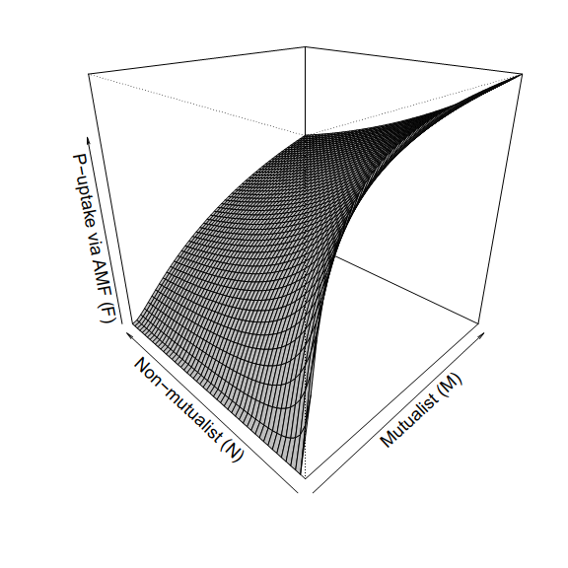

(B)  
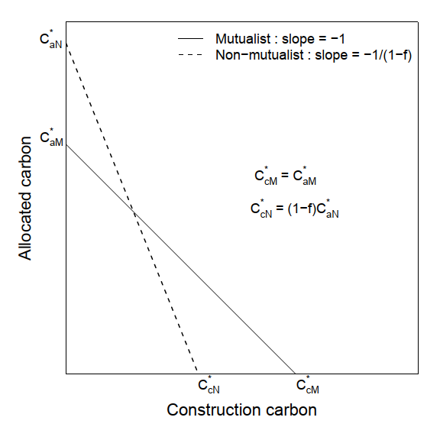

Figure 1: *(A)* P-uptake via mycorrhizal fungi *F(M,N)* as a function of densities of mutualists (M) and non-mutualist (N). M and N vary over range (0,100). *(B)* Schematic diagram depicting the condition for stable co-existence of both symbionts.

Figure 2: *(A)* For fidelity *f = 0.3*: Zero net growth isoclines (ZNGI) for both symbionts intersect at a common point which indicates stable co-existence of mutualist and non-mutualist. Two trajectories in the resource carbons’ phase space initiated at (0.1, 0.1) reached to that common point for *Cc0* *= 5* and *25*. *(B)* Solution of Equation (1) and (4): dynamics of allocated carbon (*Ca*) and construction carbon (*Cc*) respectively against time for *Cc0* *= 5*. *(C)* Solution of Equation (2) and (3): dynamics of mutualist (*M*) and non-mutualist (*N*) against time for *Cc0* *= 5*. *(D - E)* same as described for (*B - C*) but with *Cc0 = 25. (F)* Variation of equilibrium values of (${\hat{C_{c}}}/{\hat{C_{a}}}$) and (${\hat{N}}/{\hat{M}}$) against *Cc0* : construction carbon remained always greater than allocated carbon (green solid line above black dotted line at 1) as it was invested in both symbionts, similarly with increasing greater storage of source construction carbon-density (*Cc0*) in the plant, non-mutualist dominated over mutualist in co-existing population.

(B)  
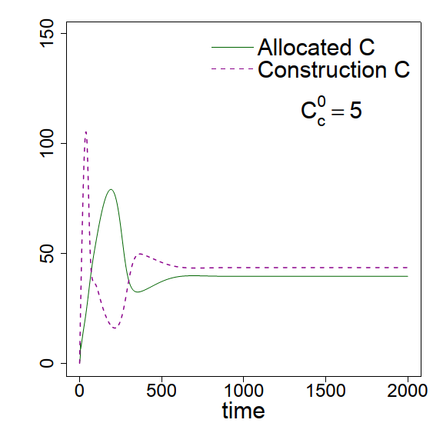

(C)  
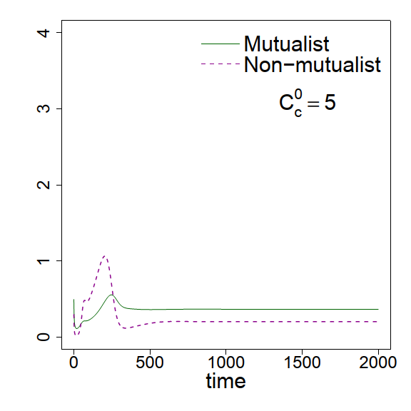

(D)  
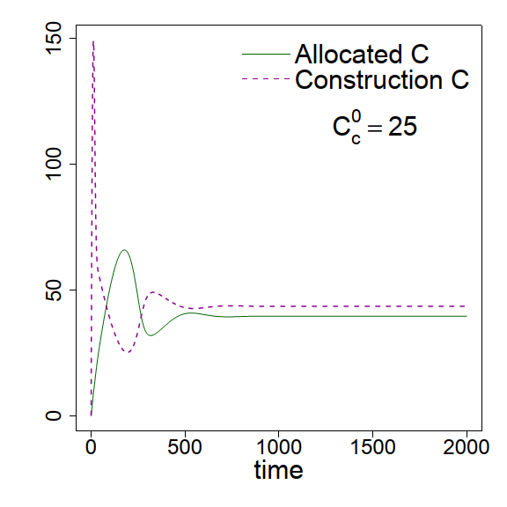

(E)  
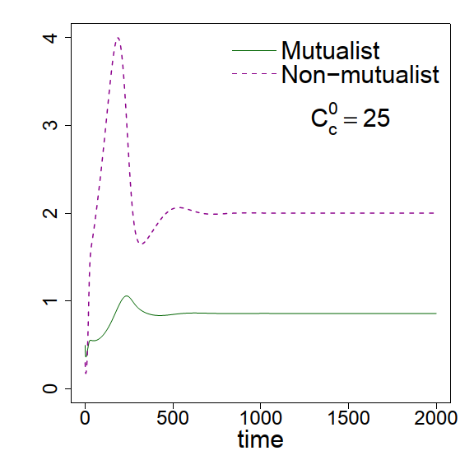

(F)  
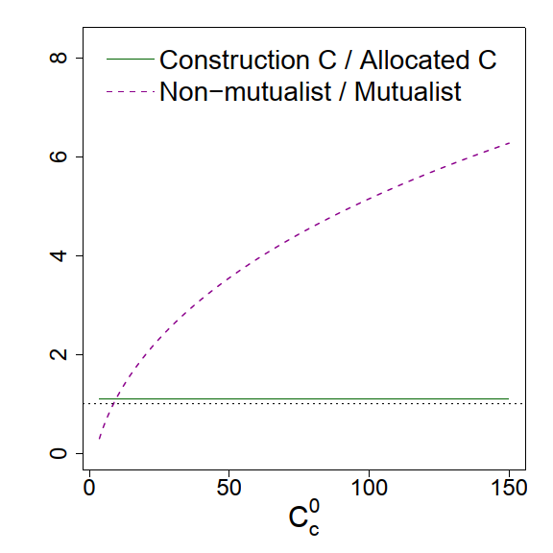

(A)  
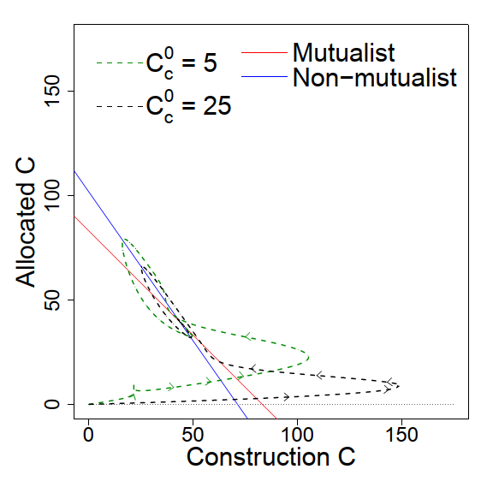

**Acknowledgements**

**Literature Cited**

**Appendix:**

**A1: Equilibrium solution for allocated carbon, construction carbon and both symbionts**

Solving equations (5) to (8), we get equilibrium solutions for allocated carbon ($\hat{C_{a}}$), construction carbon ($\hat{C_{c}}$), mutualist ($\hat{M}$) and non-mutualist ($\hat{N}$) (given a finite phosphorous uptake per unit of preferentially allocated carbon received by mutualists (u)) as follows;

| $$\hat{C_{a}}={(1-P_{s})}/{F\left(\hat{M}, \hat{N}\right)};F\left(\hat{M}, \hat{N}\right)=u\left[\frac{\hat{M}}{K_{c}+\hat{M}}\right]\left[\frac{{\hat{M}}/{\left(\hat{M}+\hat{N}\right)}}{1-f+f\left[{\hat{M}}/{\left(\hat{M}+\hat{N}\right)}\right]}\right]$$ $${\hat{C_{c}}=C}_{c}^{0}/g\left(\hat{M}+\hat{N}\right)$$ $\hat{M}= \frac{-α_{2}+\sqrt{α_{2}^{2}-4α_{1}α_{3}}}{2α_{1}}$ $$\hat{N}= β-\hat{M}$$ Where, $$α_{1}=\frac{K_{M}duβ}{b_{max}\left(1-s\right)-d}-\frac{C_{c}^{0}u}{g}-βf(1-P_{s})$$ $$α_{2}=-\left(1-P_{s}\right)K_{c}βf-β^{2}(1-f)(1-P_{s})$$ $$α_{3}=-(1-P_{s})(1-f)K_{c}β^{2}$$ $$β=\frac{-{fC_{c}^{0}}/{g(1-f)}}{d\left[\frac{K_{M}}{b_{max}\left(1-s\right)-d}-\frac{K_{N}}{(b_{max}-d){(1-f)}^{2}}\right]}$$ |  |
| --- | --- |

We plot each of these equilibrium values ($\hat{C_{a}}$, $\hat{C_{c}}$, $\hat{M}$ and $\hat{N}$) against fidelity (*f*)

(G)  
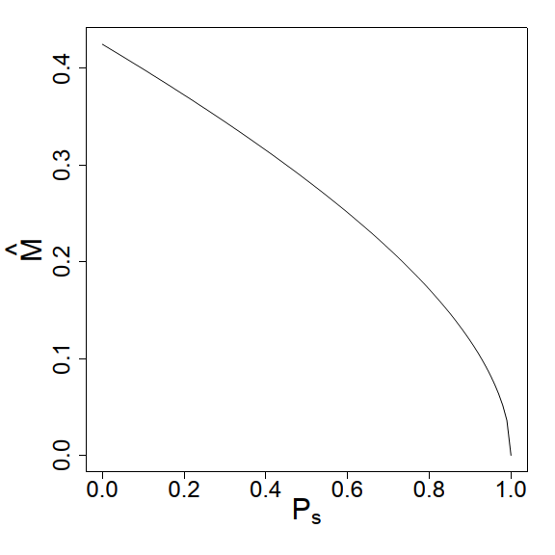

(H)  
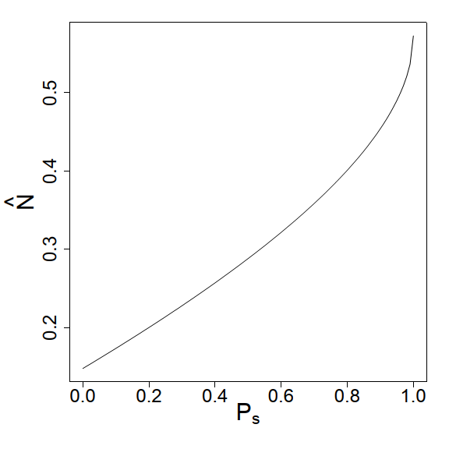

(F)  
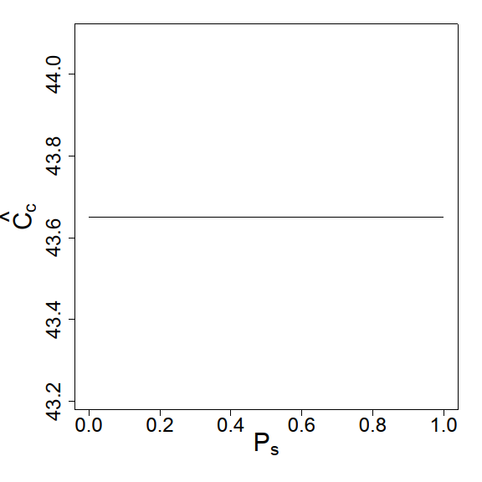

(E)  
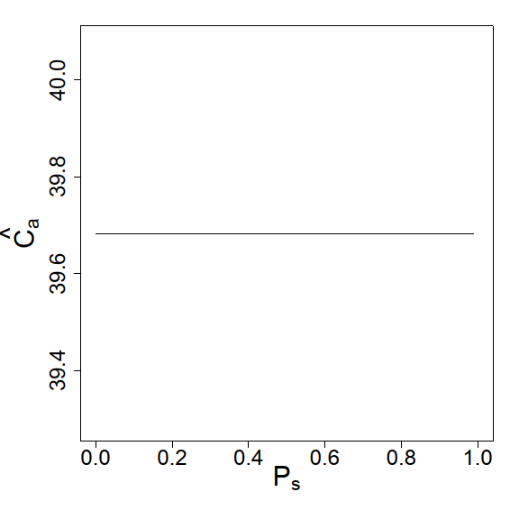

(D)  
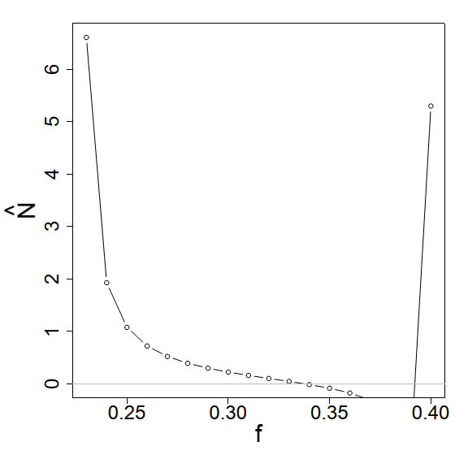

(C)  
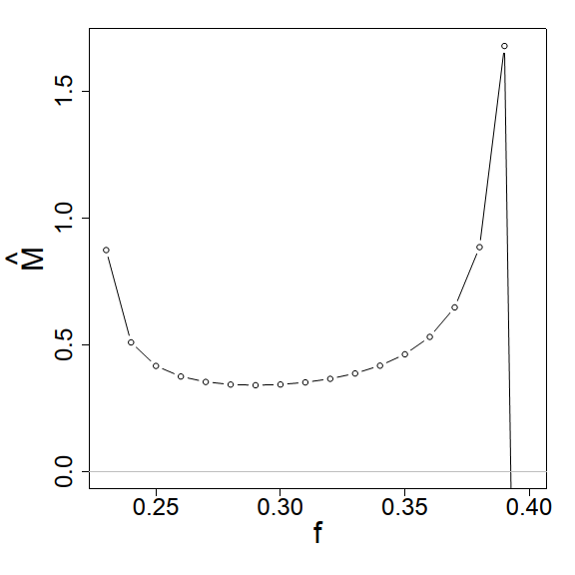

(B)  
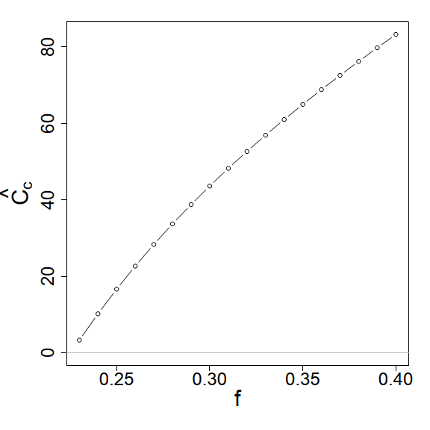

(A)  
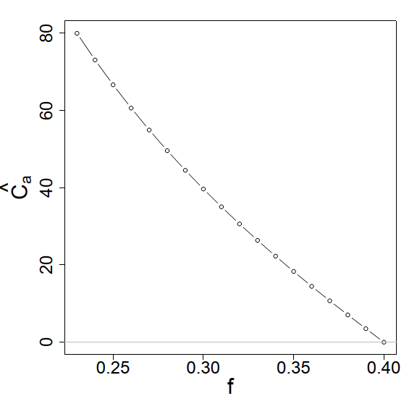

Figure A1: Equilibrium solution for *(A)* allocated carbon ($\hat{C_{a}}$), *(B)* construction carbon ($\hat{C_{c}}$), *(C)* mutualist ($\hat{M}$) and *(D)* non-mutualist ($\hat{N}$) are plotted against fidelity (*f*), other parameters used as

Figure A2: *(A)* For fidelity *f = 0.2*: Zero net growth isoclines (ZNGI) for both symbionts do not intersect no coexistence of both symbionts is possible (Equation 7 is not satisfied, *CaN* / CaM\** < *1*). Trajectories in the resource carbons’ phase space initiated at (0.1, 0.1) diverged for *Cc0* *= 5.* *(B)* Solution of Equation (1) and (4): dynamics of allocated carbon (*Ca*) and construction carbon (*Cc*) against time for *Cc0* *= 5*. *(C)* Solution of Equation (2) and (3): dynamics of mutualist (*M*) and non-mutualist (*N*) against time for *Cc0* *= 5*. The system showed unrealistic numerical solution as construction carbon (*Cc*) become negative after a short time. Fidelity was also not sufficient to compensate mutualist’s need for energetic cost (*s = 0.3*), so mutualist became rare in that system whereas non-mutualist grew abundantly. Non-mutualist only uptake resources from the plant without adding any benefit, so the system collapsed.

(A)  
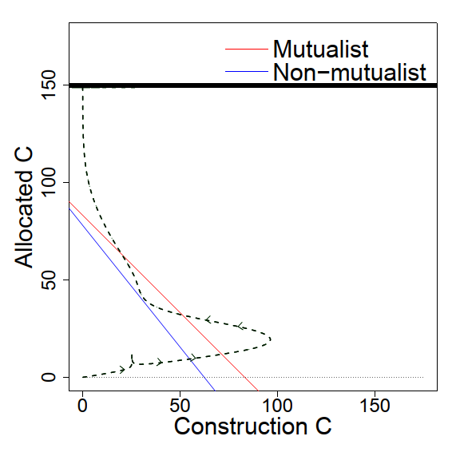

(B)  
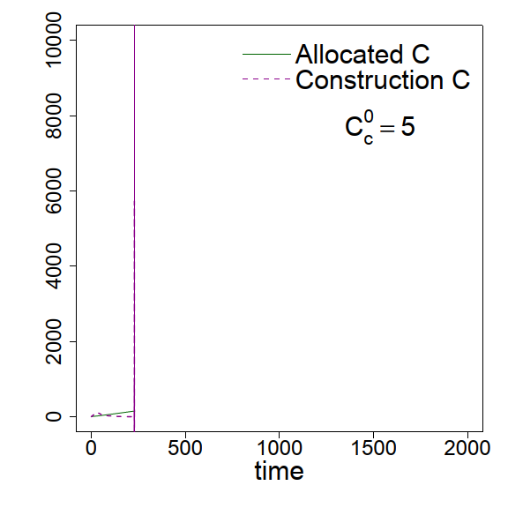

(C)  
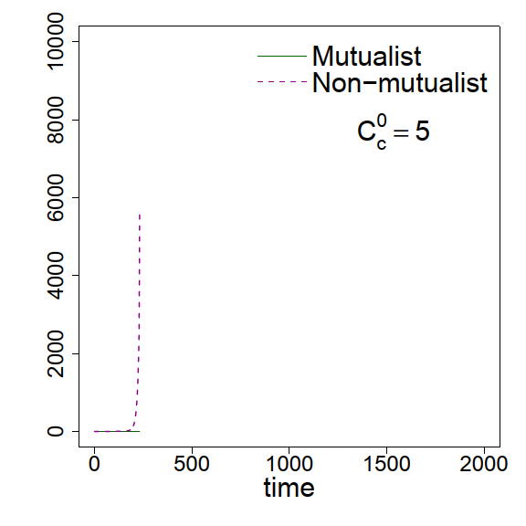

(E)  
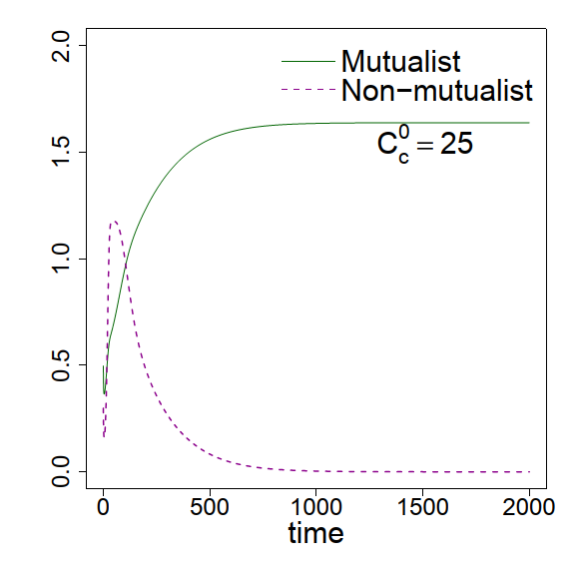

(D)  
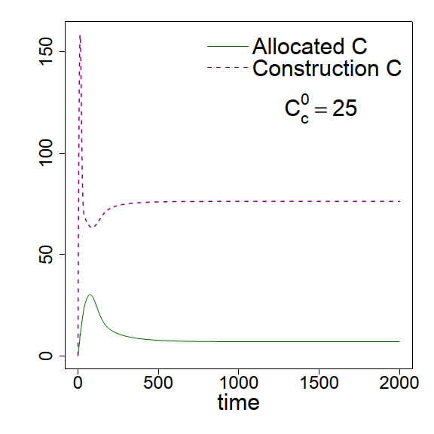

(C)  
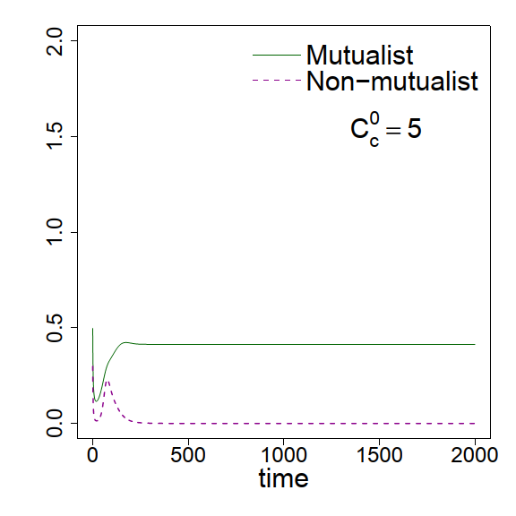

(B)  
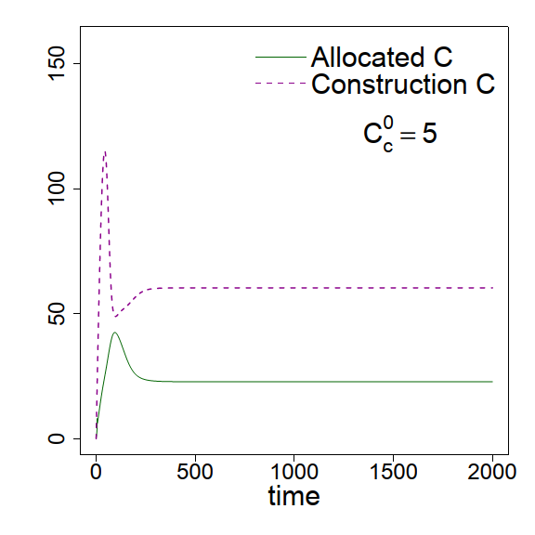

(A)  
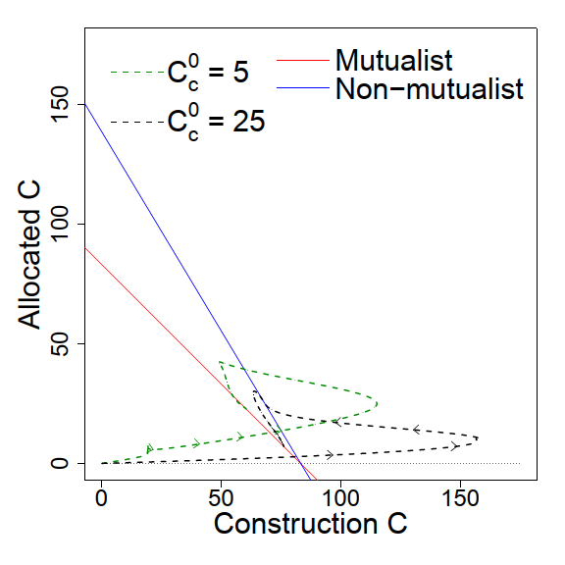

Figure A3: *(A)* For fidelity *f = 0.4*: Zero net growth isoclines (ZNGI) for both symbionts intersect at zero line and as absolute slope of mutualist’s ZNGI is less than that of non-mutualist, mutualist always win over non-mutualist and no coexistence of both symbionts is possible (Equation 7 is not satisfied). Two trajectories in the resource carbons’ phase space initiated at (0.1, 0.1) reached to two different equilibrium values for *Cc0* *= 5* and *25*. *(B)* Solution of Equation (1) and (4): dynamics of allocated carbon (*Ca*) and construction carbon (*Cc*) against time for *Cc0* *= 5*. *(C)* Solution of Equation (2) and (3): dynamics of mutualist (*M*) and non-mutualist (*N*) against time for *Cc0* *= 5*. *(D - E)* same as described for (*B - C*) but with *Cc0* *= 25.*  Increased fidelity added an advantage to the mutualist-abundance.